Task 1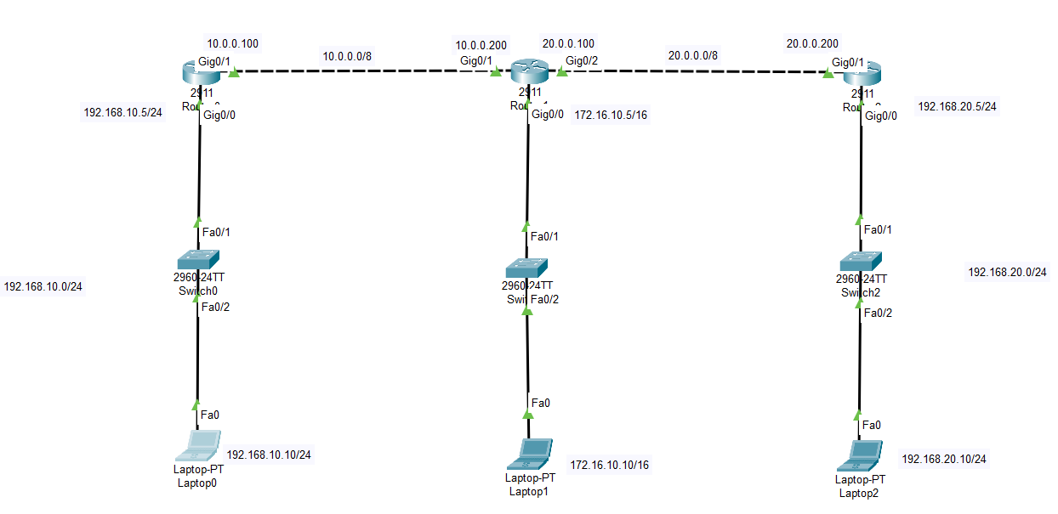

Router0:

Router#conf

Configuring from terminal, memory, or network [terminal]?

Enter configuration commands, one per line. End with CNTL/Z.

Router(config)#interface gigabitEthernet 0/0

Router(config-if)#ip address 192.168.10.5 255.255.255.0

Router(config-if)#no shutdown

Router(config-if)#

%LINK-5-CHANGED: Interface GigabitEthernet0/0, changed state to up

%LINEPROTO-5-UPDOWN: Line protocol on Interface GigabitEthernet0/0, changed state to up

Router(config-if)#exit

Router(config)#interface gigabitEthernet 0/1

Router(config-if)#ip address 10.0.0.100 255.0.0.0

Router(config-if)#no shutdown

Router(config-if)#

%LINK-5-CHANGED: Interface GigabitEthernet0/1, changed state to up

Router(config-if)#exit

Router(config)#exit

Router#

%SYS-5-CONFIG_I: Configured from console by console

Router#copy running-config startup-config

Destination filename [startup-config]?

Building configuration...

[OK]

Router#hostname R1

^

% Invalid input detected at '^' marker.

Router#conf

Configuring from terminal, memory, or network [terminal]?

Enter c

R1#copy running-config startup-config

Destination filename [startup-config]?

Building configuration...

[OK]

R0(config)#ip route 172.16.0.0 255.255.0.0 10.0.0.200

R0(config)#ip route 192.168.20.0 255.255.255.0 10.0.0.200

Router1 :

Router#conf

Configuring from terminal, memory, or network [terminal]?

Enter configuration commands, one per line. End with CNTL/Z.

Router(config)#hostname R2

R2(config)#interface gigabitEthernet 0/1

R2(config-if)#ip address 10.0.0.200 255.0.0.0

R2(config-if)#no shutdown

R2(config-if)#

%LINK-5-CHANGED: Interface GigabitEthernet0/1, changed state to up

%LINEPROTO-5-UPDOWN: Line protocol on Interface GigabitEthernet0/1, changed state to up

R2(config-if)#exit

R2(config)#interface gigabitEthernet 0/0

R2(config-if)#ip address 172.16.10.5 255.255.0.0

R2(config-if)#no shutdown

R2(config-if)#

%LINK-5-CHANGED: Interface GigabitEthernet0/0, changed state to up

%LINEPROTO-5-UPDOWN: Line protocol on Interface GigabitEthernet0/0, changed state to up

R2(config-if)#exit

R2(config)#interface gigabitEthernet 0/2

R2(config-if)#ip address 20.0.0.100 255.0.0.0

R2(config-if)#no shutdown

R2(config-if)#

%LINK-5-CHANGED: Interface GigabitEthernet0/2, changed state to up

R2(config-if)#copy running-config startup-config

^

% Invalid input detected at '^' marker.

R2(config-if)#exit

R2(config)#copy running-config startup-config

^

% Invalid input detected at '^' marker.

R2(config)#exit

R2#

%SYS-5-CONFIG_I: Configured from console by console

R2#copy

% Incomplete command.

R2#copy running-config startup-config

Destination filename [startup-config]?

Building configuration...

[OK]

R1(config)#ip route 192.168.10.0 255.255.255.0 10.0.0.100

R1(config)#ip route 192.168.20.0 255.255.255.0 20.0.0.200

Router2:

Router>en

Router#conf

Configuring from terminal, memory, or network [terminal]?

Enter configuration commands, one per line. End with CNTL/Z.

Router(config)#interface gigabitEthernet 0/1

Router(config-if)#ip address 20.0.0.200 255.0.0.0

Router(config-if)#no shutdown

Router(config-if)#

%LINK-5-CHANGED: Interface GigabitEthernet0/1, changed state to up

%LINEPROTO-5-UPDOWN: Line protocol on Interface GigabitEthernet0/1, changed state to up

Router(config-if)#exit

Router(config)#interface gigabitEthernet 0/0

Router(config-if)#ip address 192.168.20.5 255.255.255.0

Router(config-if)#no shutdown

Router(config-if)#

%LINK-5-CHANGED: Interface GigabitEthernet0/0, changed state to up

%LINEPROTO-5-UPDOWN: Line protocol on Interface GigabitEthernet0/0, changed state to up

Router(config-if)#exit

Router(config)#exit

Router#

%SYS-5-CONFIG_I: Configured from console by console

Router#show

% Incomplete command.

Router#show?

show

Router#show

% Incomplete command.

Router#show?

show

Router#show ip route

Codes: L - local, C - connected, S - static, R - RIP, M - mobile, B - BGP

D - EIGRP, EX - EIGRP external, O - OSPF, IA - OSPF inter area

N1 - OSPF NSSA external type 1, N2 - OSPF NSSA external type 2

E1 - OSPF external type 1, E2 - OSPF external type 2, E - EGP

i - IS-IS, L1 - IS-IS level-1, L2 - IS-IS level-2, ia - IS-IS inter area

* - candidate default, U - per-user static route, o - ODR

P - periodic downloaded static route

Gateway of last resort is not set

20.0.0.0/8 is variably subnetted, 2 subnets, 2 masks

C 20.0.0.0/8 is directly connected, GigabitEthernet0/1

L 20.0.0.200/32 is directly connected, GigabitEthernet0/1

192.168.20.0/24 is variably subnetted, 2 subnets, 2 masks

C 192.168.20.0/24 is directly connected, GigabitEthernet0/0

L 192.168.20.5/32 is directly connected, GigabitEthernet0/0

Router#copy running-config startup-config

Destination filename [startup-config]?

Building configuration...

[OK]

R2(config)#ip route 172.16.0.0 255.255.0.0 20.0.0.100

R2(config)#ip route 192.168.10.0 255.255.255.0 20.0.0.100

Task 2

RIPv2:

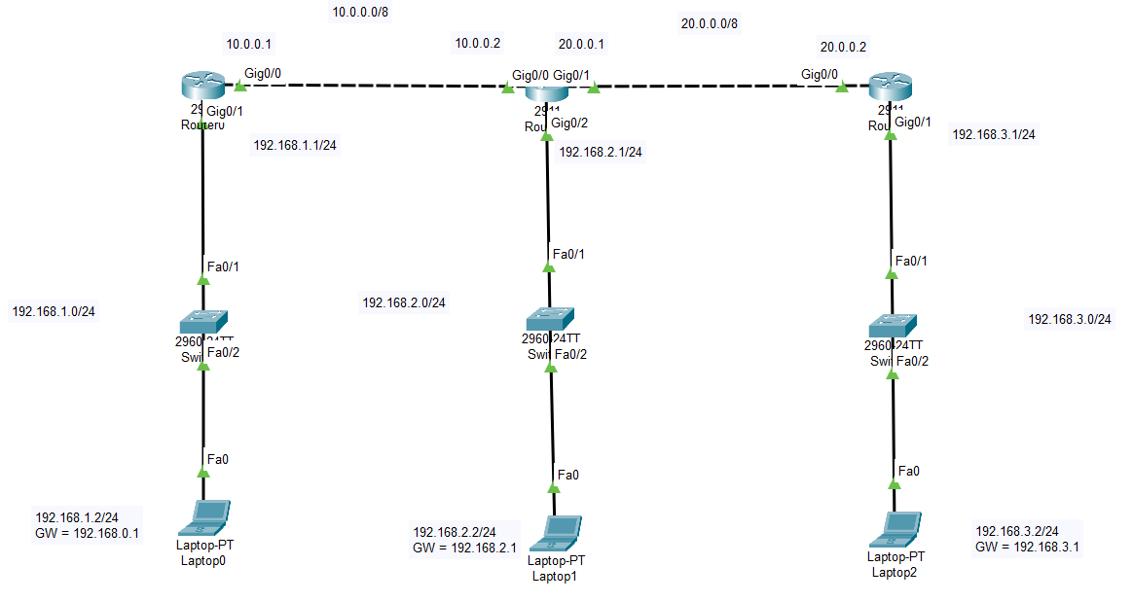

Router0:

R1(config)#interface gigabitEthernet 0/1

R1(config-if)#ip address

R1(config-if)#ip address 192.168.1.1 255.255.255.0

R1(config-if)#no shutdown

R1(config-if)#

%LINK-5-CHANGED: Interface GigabitEthernet0/1, changed state to up

%LINEPROTO-5-UPDOWN: Line protocol on Interface GigabitEthernet0/1, changed state to up

R1(config-if)#exit

R1(config)#interface gigabitEthernet 0/0

R1(config-if)#ip address 10.0.0.1 255.0.0.0

R1(config-if)#no shutdown

Rip config:

R1(config)#router rip

R1(config-router)#version 2

R1(config-router)#network 10.0.0.0

R1(config-router)#network 192.168.1.0

R1(config-router)#exit

R1(config)#

Router1:

R1(config)#interface gigabitEthernet 0/0

R1(config-if)#ip address 10.0.0.2

% Incomplete command.

R1(config-if)#ip address 10.0.0.2 255.0.0.0

R1(config-if)#no shutdown

R1(config-if)#

%LINK-5-CHANGED: Interface GigabitEthernet0/0, changed state to up

%LINEPROTO-5-UPDOWN: Line protocol on Interface GigabitEthernet0/0, changed state to up

R1(config-if)#exit

R1(config)#interface gigabitEthernet 0/2

R1(config-if)#ip address 192.168.2.1 255.255.255.0

R1(config-if)#no shutdown

R1(config-if)#

%LINK-5-CHANGED: Interface GigabitEthernet0/2, changed state to up

%LINEPROTO-5-UPDOWN: Line protocol on Interface GigabitEthernet0/2, changed state to up

R1(config-if)#exit

R1(config)#interface gigabitEthernet 0/1

R1(config-if)#ip address 20.0.0.1 255.0.0.0

R1(config-if)#no shutdown

Ripv2 config:

R1(config)#router rip

R1(config-router)#version 2

R1(config-router)#network 10.0.0.0

R1(config-router)#network 20.0.0.0

R1(config-router)#network 192.168.2.0

R1(config-router)#exit

Router2:

Router(config)#interface gigabitEthernet 0/0

Router(config-if)#ip address 20.0.0.2 255.0.0.0

Router(config-if)#no shutdown

Router(config-if)#

%LINK-5-CHANGED: Interface GigabitEthernet0/0, changed state to up

%LINEPROTO-5-UPDOWN: Line protocol on Interface GigabitEthernet0/0, changed state to up

Router(config-if)#ex

Router(config)#interface gigabitEthernet 0/1

Router(config-if)#ip address 192.168.3.1 255.255.255.0

Router(config-if)#no shutdown

Ripv2 config:

Router(config)#router rip

Router(config-router)#version 2

Router(config-router)#network 20.0.0.0

Router(config-router)#network 192.168.3.0

Router(config-router)#exit

Task 3

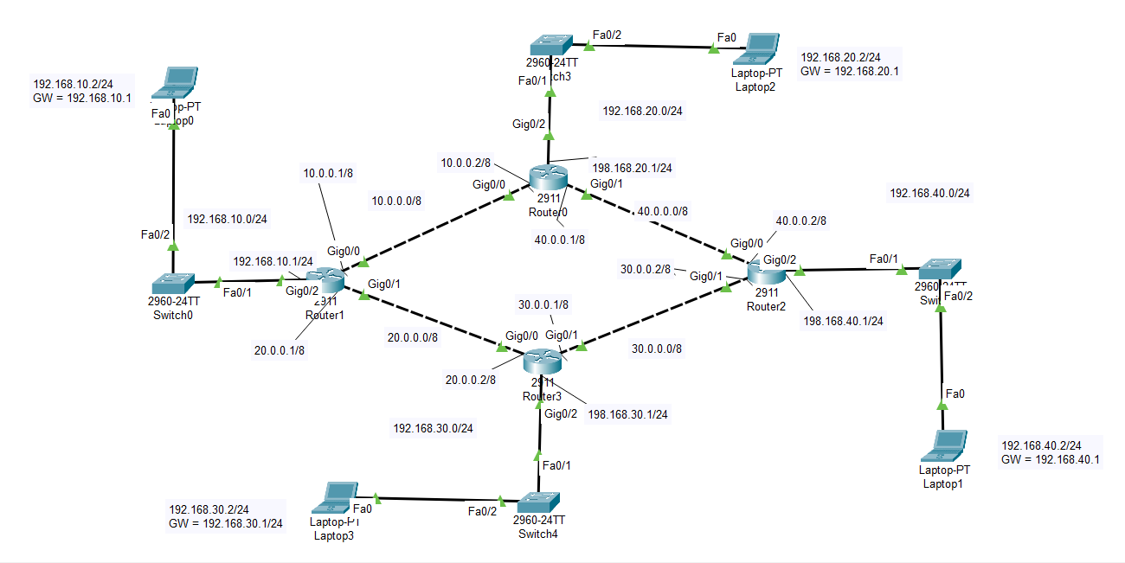

Router1 :

R0(config)#interface gigabitEthernet 0/2

R0(config-if)#ip address 192.168.10.1 255.255.255.0

R0(config-if)#no shutdown

R0(config-if)#

%LINK-5-CHANGED: Interface GigabitEthernet0/2, changed state to up

%LINEPROTO-5-UPDOWN: Line protocol on Interface GigabitEthernet0/2, changed state to up

R0(config-if)#exit

R0(config)#interface gigabitEthernet 0/0

R0(config-if)#ip address 10.0.0.1 255.0.0.0

R0(config-if)#no shutdown

R0(config-if)#

%LINK-5-CHANGED: Interface GigabitEthernet0/0, changed state to up

R0(config-if)#exit

R0(config)#interface gigabitEthernet 0/1

R0(config-if)#ip address 20.0.0.1 255.0.0.0

R0(config-if)#no shutdown

R0(config-if)#

%LINK-5-CHANGED: Interface GigabitEthernet0/1, changed state to up

RIPv2

R0(config)#router rip

R0(config-router)#version 2

R0(config-router)#network 192.168.10.0

R0(config-router)#network 10.0.0.0

R0(config-router)#network 20.0.0.0

R0(config-router)#exit

R0(config)#

Router 0 :

Router(config)#interface gigabitEthernet 0/2

Router(config-if)#ip address 192.168.20.1 255.255.255.0

Router(config-if)#no shutdown

Router(config-if)#

%LINK-5-CHANGED: Interface GigabitEthernet0/2, changed state to up

%LINEPROTO-5-UPDOWN: Line protocol on Interface GigabitEthernet0/2, changed state to up

Router(config-if)#exit

Router(config)#interface gigabitEthernet 0/0

Router(config-if)#ip address 10.0.0.2 255.0.0.0

Router(config-if)#no shutdown

Router(config-if)#

%LINK-5-CHANGED: Interface GigabitEthernet0/0, changed state to up

%LINEPROTO-5-UPDOWN: Line protocol on Interface GigabitEthernet0/0, changed state to up

Router(config-if)#interface gigabitEthernet 0/1

Router(config-if)#ip address 40.0.0.1 255.0.0.0

Router(config-if)#no shutdown

Router(config-if)#

%LINK-5-CHANGED: Interface GigabitEthernet0/1, changed state to up

RIPv2:

Router(config)#router rip

Router(config-router)#version 2

Router(config-router)#network 10.0.0.0

Router(config-router)#network 192.168.20.0

Router(config-router)#network 40.0.0.0

Router(config-router)#exit

Router3:

Router(config)#interface gigabitEthernet 0/0

Router(config-if)#ip address 20.0.0.2 255.0.0.0

Router(config-if)#no shutdown

Router(config-if)#

%LINK-5-CHANGED: Interface GigabitEthernet0/0, changed state to up

%LINEPROTO-5-UPDOWN: Line protocol on Interface GigabitEthernet0/0, changed state to up

Router(config-if)#exit

Router(config)#interface gigabitEthernet 0/1

Router(config-if)#ip address 30.0.0.1 255.0.0.0

Router(config-if)#no shutdown

Router(config-if)#

%LINK-5-CHANGED: Interface GigabitEthernet0/1, changed state to up

Router(config-if)#exit

Router(config)#interface gigabitEthernet 0/2

Router(config-if)#ip address 192.168.30.1 255.255.255.0

Router(config-if)#no shutdown

Router(config-if)#

%LINK-5-CHANGED: Interface GigabitEthernet0/2, changed state to up

%LINEPROTO-5-UPDOWN: Line protocol on Interface GigabitEthernet0/2, changed state to up

RIPv2:

Router(config)#router rip

Router(config-router)#version 2

Router(config-router)#network 20.0.0.0

Router(config-router)#network 30.0.0.0

Router(config-router)#network 192.168.30.0

Router(config-router)#exit

Router2 :

Router(config)#interface gigabitEthernet 0/0

Router(config-if)#ip address 40.0.0.2 255.0.0.0

Router(config-if)#no shutdown

Router(config-if)#

%LINK-5-CHANGED: Interface GigabitEthernet0/0, changed state to up

%LINEPROTO-5-UPDOWN: Line protocol on Interface GigabitEthernet0/0, changed state to up

Router(config-if)#interface gigabitEthernet 0/1

Router(config-if)#ip address 30.0.0.2 255.0.0.0

Router(config-if)#no shutdown

Router(config-if)#

%LINK-5-CHANGED: Interface GigabitEthernet0/1, changed state to up

%LINEPROTO-5-UPDOWN: Line protocol on Interface GigabitEthernet0/1, changed state to up

Router(config-if)#interface gigabitEthernet 0/2

Router(config-if)#ip address 192.168.40.1 255.0.0.0

Router(config-if)#no shutdown

Router(config-if)#

%LINK-5-CHANGED: Interface GigabitEthernet0/2, changed state to up

%LINEPROTO-5-UPDOWN: Line protocol on Interface GigabitEthernet0/2, changed state to up

RIPv2:

Router(config)#router rip

Router(config-router)#version 2

Router(config-router)#network 40.0.0.0

Router(config-router)#network 30.0.0.0

Router(config-router)#network 192.168.40.0

Router(config-router)#exit